Scripts for Scene: **ControlRoom_LEFT**

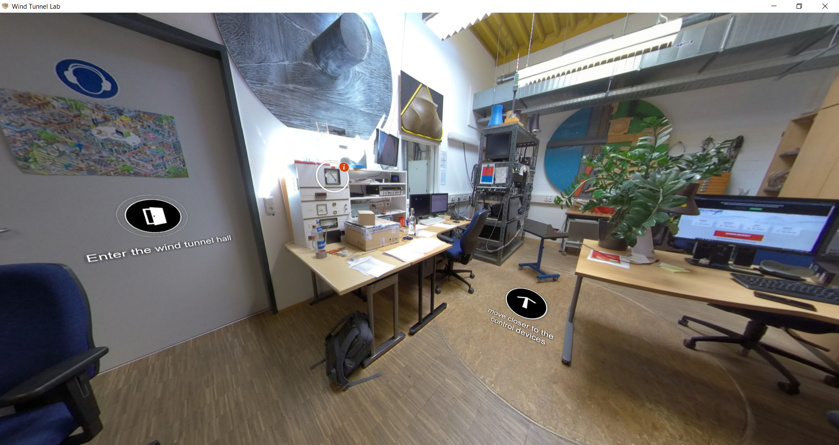

|  |  |  |
| --- | --- | --- |
| Nr | Hotspot (see red arrow) | Script |
| 1 | Hotspot: Ambient pressure | Slide Figures/Album (with text):  Slide 1-Figure :    Slide 1-Text :  To give the information of the ambient pressure in the wind tunnel, a display of measured ambient pressure is displayed here. The unit is Torr.  Slide 2-Figure:    Slide 2-Text:  Torr unit is a unit of pressure which 1 Torr equals to one millimeter of mercury (133.322 Pa). In other way, it can be also defined as 1/760 atm of a standard atmosphere (1 atm = 101 325 Pa). It was named after Evangelista Torricelli (1608-1647), an Italian physicist and mathematician from Italy who also discovered the principle of the barometer in 1644. (Source Figure: Photo Researchers / Mary Evans Picture Library)  Slide-3 Figure:    Slide-3 Text:  In general, a mercury barometer consists of glass tube which is closed at one end and opened at the other end. The open-end of the tube ends with mercury-filled reservoir. Due to the weight of mercury, there is a small vacuum area at the top. The higher atmospheric pressure will add more force on the reservoir, which will increase the height of mercury level in the tube. For lower atmospheric pressure, the mercury in the tube will drop. (Source Figure: https://instrumentationtools.com/)  Slide-4 Text:  References:  [1] A. Sella. *Toricelli’s Barometer,* accessed on 29 September 2022. https://www.chemistryworld.com/opinion/torricellis-barometer/1017293.article  [2] Editorial Staff of Instrumentation Tools. *What is a barometer?,* accessed on 1 October 2022. https://instrumentationtools.com/what-is-a-barometer/  How the slide Figure is displayed: |
| 2 | Hotspot: Technician | Script only:  The technician will help you to perform an experiment in the wind tunnel, the installation of the model, as well as the troubleshooting in the experiment. |
| 3 | Hotspot: Short background of the experiments | Slide Figures/Album (with text):  Slide 1-Figure : Figure changed due to clarity issues    Slide 1-Text :  In this session, we will virtually experience an example experiment of two-in-line grouped cylinders under wind load. The experiment is performed to investigate the interference effects in grouped cylinders. Additionally, the available experimental setup, which are related to the investigation of aeroelasticity and across-wind actions on a slender structure, can also be observed through this virtual tour. (shifted)  Slide 2-Figure :    Slide 2-Text :  When grouped cylinders are placed closely next to each other, and with the incoming wind, a state of flow around the cylinders can change. Due to the existence of other bodies, the wakes from each of the cylinder will interact. This is called interference effect. It changes the state of flow around the bodies. An interaction can occur, for example, between boundary layers, wake-boundary layers, or wakes from each of the cylinders. This depends on the distance between the cylinders, Reynolds numbers, and the incoming wind direction. Such phenomenon often occurs between the two chimneys in stacks or between the towers of wind turbine in the transportation. (Source Figure: Alam & Meyer, 2003)  Slide 3-Figure :    Slide 3-Text :  As mentioned previously, in the transportation of wind turbine towers, the interference effect between the grouped towers can occur. In the process of transportation, the towers must be placed closely next to each other. Sometimes, the towers must stood by the bay in months long before getting transported into the offshore. In this period, the towers are prone to the interference effect where it can lead to the critical interference galloping, a self-sustained oscillation. (Source Figure: Paul Ellis | AFP | Getty Images)  Slide 4-Figure :    Slide 4-Text :  In fact, at the same time of the tower being prone to the interference galloping, chimney and slender tower such as these also can experience Vortex-Induced Vibration. Vortex-Induced Vibration is a phenomenon of a locked-in oscillation when the frequency of vortex shedding is around the natural frequency of the tower. This is a very delicate and interesting phenomenon where it involves the aeroelasticity, where a fluid and structure interact. To further supplement the introductory knowledge regarding experimental setup to investigate such matters, forced-vibration and free-vibration test setup with horizontal model are elaborated in this virtual tour. This means, the experiment will treat the case study as 2-D cross-section of the cylinder (???).  Slide-5 Text:  References:  [1] M. M. Alam, J. P. Meyer. 2013. Global aerodynamics instability of twin cylinders in  cross flow. Journal of Fluid and Structures 41, pages 135-145.  [2] P. Ellis. 2012. A Siemens Gamesa blade factory on the banks of the River Humber in Hull, England on October 11, 2021., CNBC, accessed 25 September 2022, <https://www.cnbc.com/2022/02/03/siemens-gamesa-sees-revenue-drop-lowers-guidance.html>. |